

Lab 1 Report

Registered under CS Lab 02

Mingzhe Wang

Hyosik Moon

Xing Li

Table of Contents

Group Information 2

Lab Contract 2

Create a Git repository 3

Research on revert and reset 3

git checkout 3

Functionality 3

Usage scenarios 3

Experiment 4

git reset 4

Functionality 4

Usage scenarios 5

Experiment 5

git revert 6

Functionality 6

Usage scenarios 6

Experiment 6

Summary 9

Update “code.py” 10

Approach 1 10

Approach 2 10

Approach 3 13

Player and Adversary 15

First Round (Player = Hyosik, Adversary = Xing, Writer = Hyosik) 15

Second Round (Player = Xing Li, Adversary = Mingzhe Wang, Writer = Xing Li) 23

Third Round (Player = Mingzhe Wang, Adversary = Hyosik, Writer = Mingzhe Wang) 24

Summary 37

# Group Information

|  |  |  |  |
| --- | --- | --- | --- |
| Name | Student Number | McMaster Email | Enrolled Lab |
| Mingzhe Wang | 400316660 | wangm235@mcmaster.ca | CS Lab 02 (Registered) |
| Hyosik Moon | 400295620 | moonh8@mcmaster.ca | CS Lab 04 |
| Xing Li | 400292346 | li64@mcmaster.ca | CS Lab 03 |

# Lab Contract

1. There is one contact member in the group who will submit the labs: Xing Li

2. Each week there is one coordinator who is in charge of the overall lab progress. The coordinator shall be the main contributor to the lab and shall dispatch the tasks with due date if needed to make sure the lab is completed efficiently. The coordinator will be rotated in the three members of the group.

3. All members shall closely monitor the team chat channel to respond to teammates as soon as possible, no later than 12 hours. When a task is finished, the owner shall send a message in the communication channel to get all members informed.

4. Two weekly meetings are scheduled. One is on Monday from 7pm to 7:30pm for general design and dividing tasks. One is on Friday from 12:30pm to 1pm for review. The Friday meeting might be cancelled if everything goes smoothly.

5. All members will use GitHub as the repository.

6. All members will use Microsoft Teams as the major communication channel.

7. When one member cannot attend the meeting or complete tasks on time, he shall inform the whole team as early as possible.



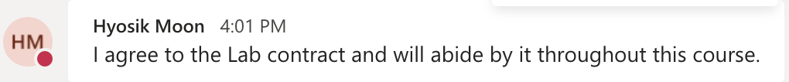

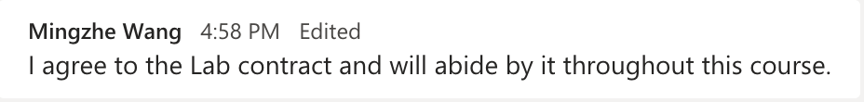

# Create a Git repository

We created a repository at GitHub. All members created a file <name>.txt, write something in it and push it to the repository.

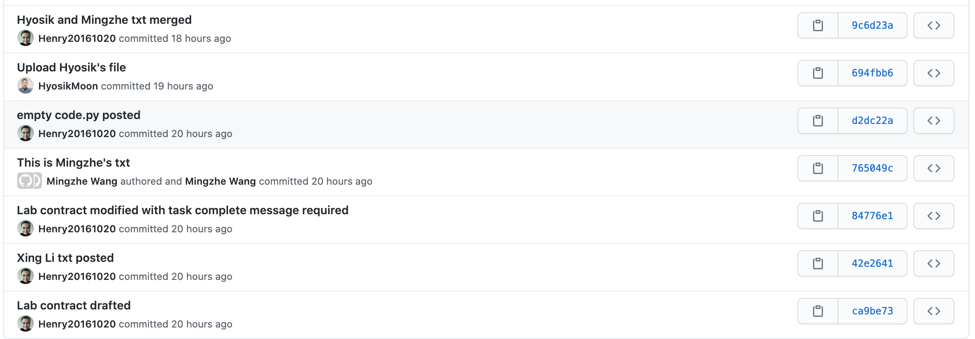

# Research on Revert and Reset

## Git Checkout

### Functionality

A checkout is an operation that moves the HEAD ref pointer to a specified commit.

### Usage scenarios

If you have modified a file in your working tree, but haven't committed the change, then you can use git checkout to checkout a fresh-from-repository copy of the file.

### Experiment

**Before:**

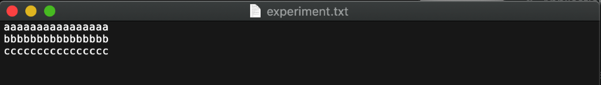

**After command:**

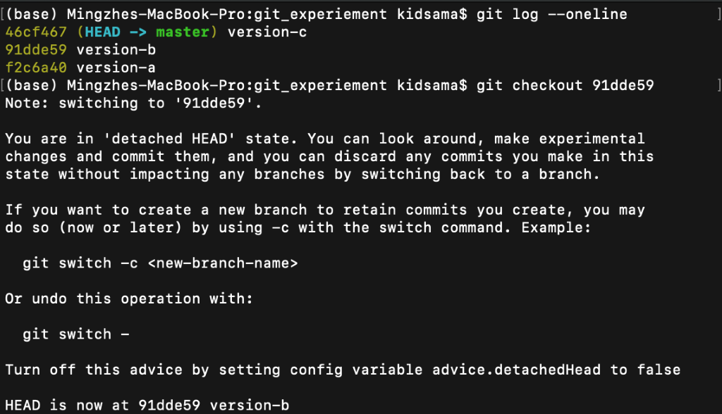

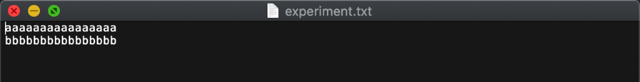

## Git Reset

### Functionality

A reset is an operation that takes a specified commit and resets the "three trees" to match the state of the repository at that specified commit.

For git reset, there are three ways to alter the staged snapshot and/or the working directory by passing it one of the following flags:

* --soft – The staged snapshot and working directory are not altered in any way.
* --mixed – The staged snapshot is updated to match the specified commit, but the working directory is not affected. This is the default option.
* --hard – The staged snapshot and the working directory are both updated to match the specified commit.

### Usage scenarios

If you have made a commit, but haven't shared it with anyone else and you decide you don't want it, then you can use git reset to rewrite the history so that it looks as though you never made that commit.

### Experiment

**Before:**

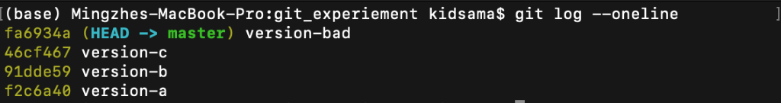

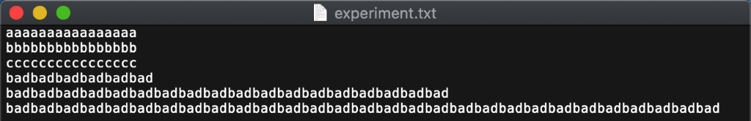

**After command:**

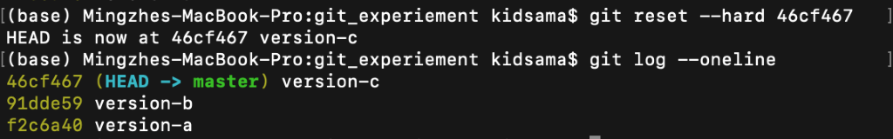

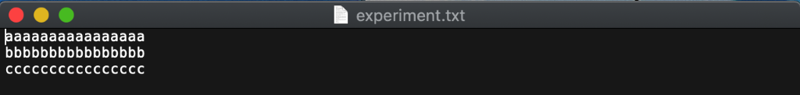

## Git Revert

### Functionality

A revert is an operation that takes a specified commit and creates a new commit which inverses the specified commit.

### Usage scenarios

If a commit has been made somewhere in the project's history, and you later decide that the commit is wrong and should not have been done, then git revert is the tool for the job. It will undo the changes introduced by the bad commit, recording the "undo" in the history.

### Experiment

**Before:**

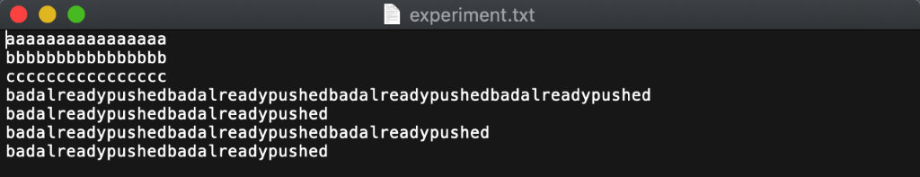

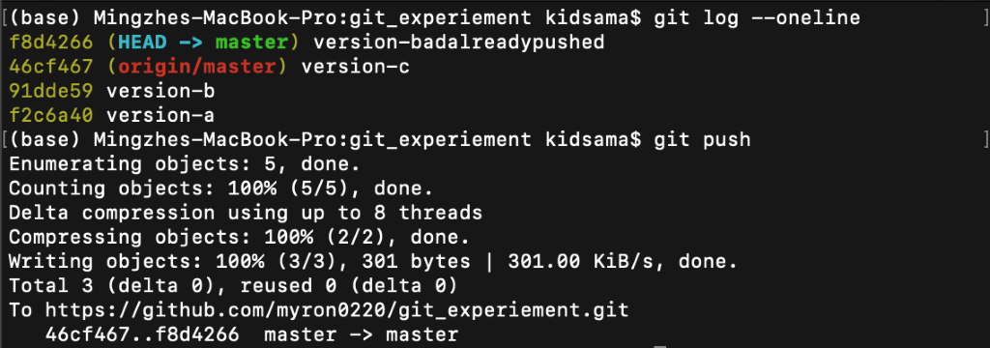

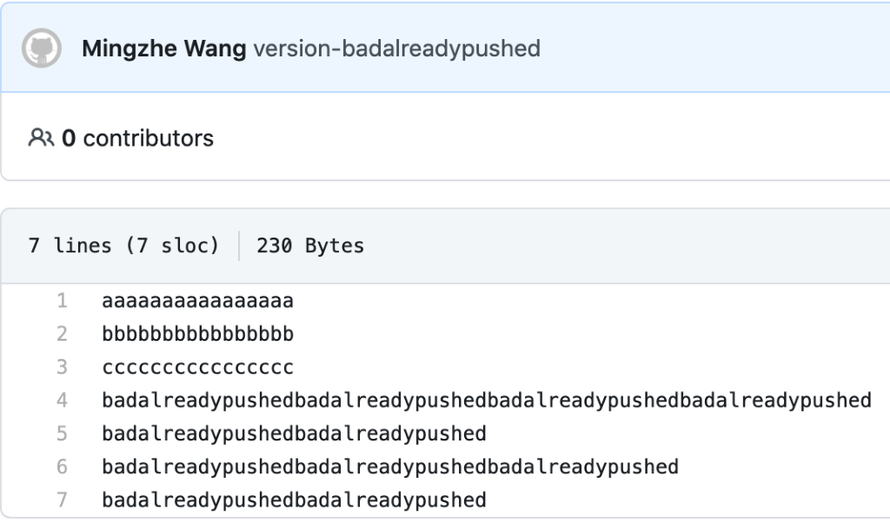

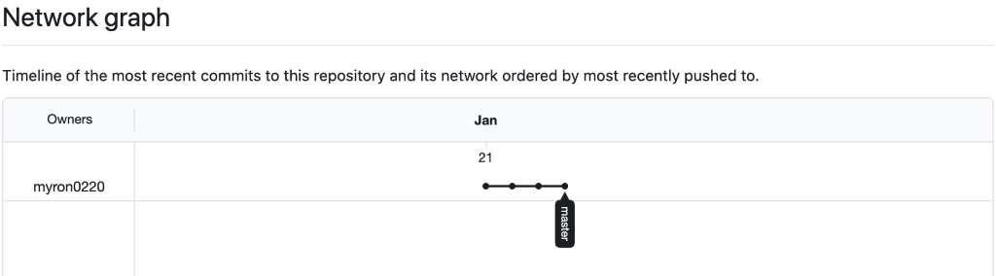

**After command:**

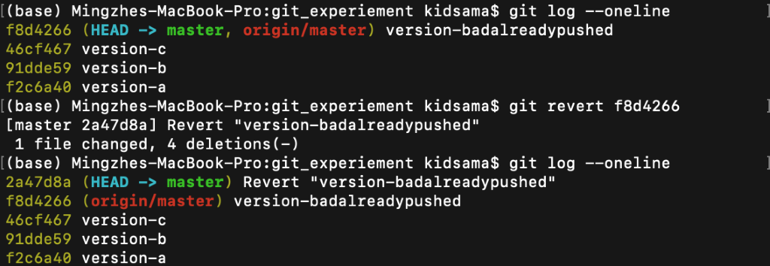

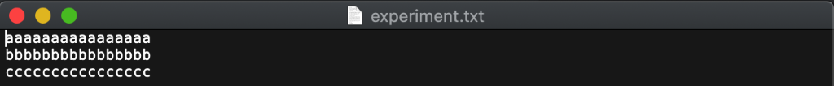

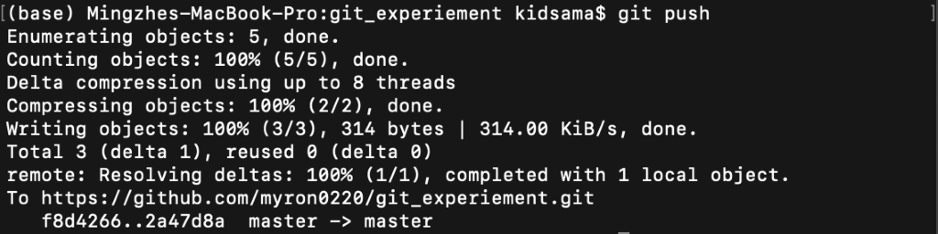

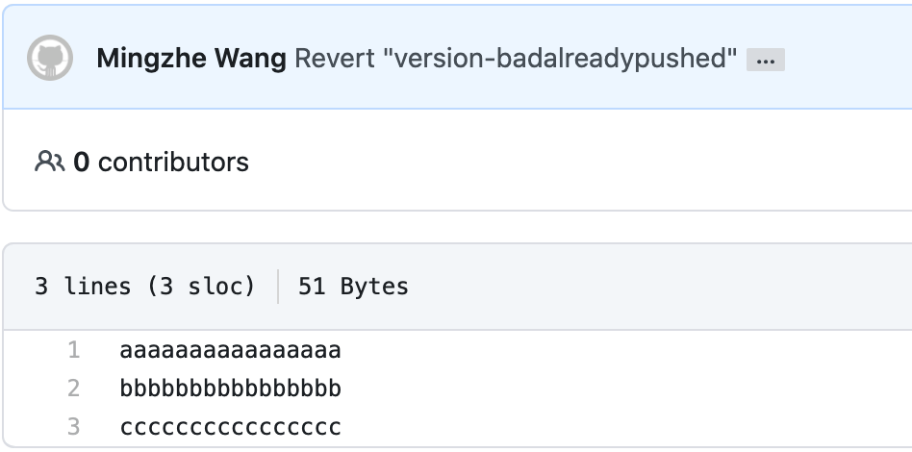

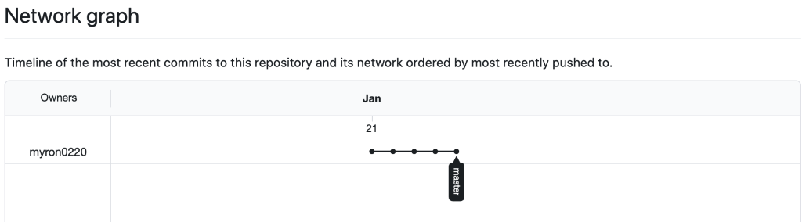

## Summary

Checkout and reset are generally used for making local or private 'undos'. They modify the history of a repository that can cause conflicts when pushing to remote shared repositories.

Revert is considered a safe operation for 'public undos' as it creates new history which can be shared remotely and doesn't overwrite history remote team members may be dependent on.

# Update “code.py”

We used different approaches to deal with the conflict.

## Approach 1

Delete the “.git” folder and load again. This is not a recommended approach, but we did experiment this at the very beginning.

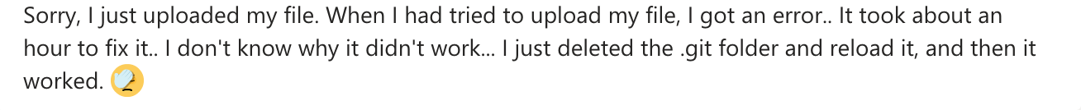

## Approach 2

Here’s another issue. When a merge was required, the terminal was disconnected. Then in the next time to pull, we were reminded to finish the previous merge first.

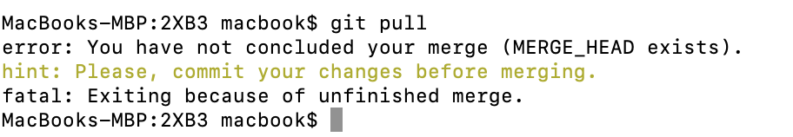

The instruction below was adopted to fix. (Retrieved from <https://stackoverflow.com/questions/11646107/you-have-not-concluded-your-merge-merge-head-exists>)

1. Undo the merge and pull again.

To undo a merge:

git merge --abort [Since git version 1.7.4]

git reset --merge [prior git versions]

1. Resolve the conflict.
2. Don't forget to add and commit the merge.
3. git pull now should work fine.

VIM is the default editor, so the VIM commands were also searched. (i for insert mode, Esc for normal mode, Retrieved from <https://coderwall.com/p/adv71w/basic-vim-commands-for-getting-started>)

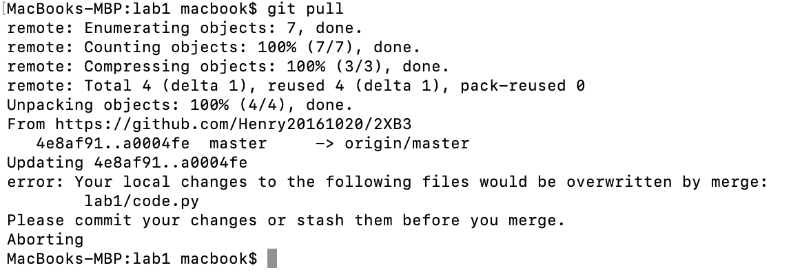

After the file “code.py” was modified, “git pull” failed because “git commit” had not been done yet.

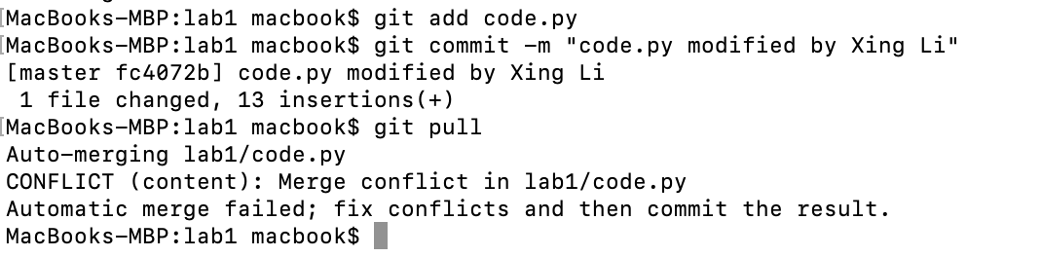

After the file “code.py” was committed, there was still conflict between origin and local.

Then we tried to branch the current local work and force pull the origin.

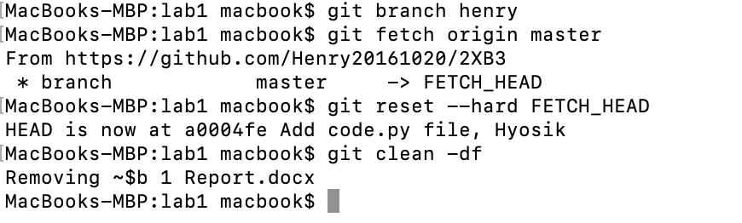

Auto merge still failed, but we could see that both codes appeared in the file “code.py”.

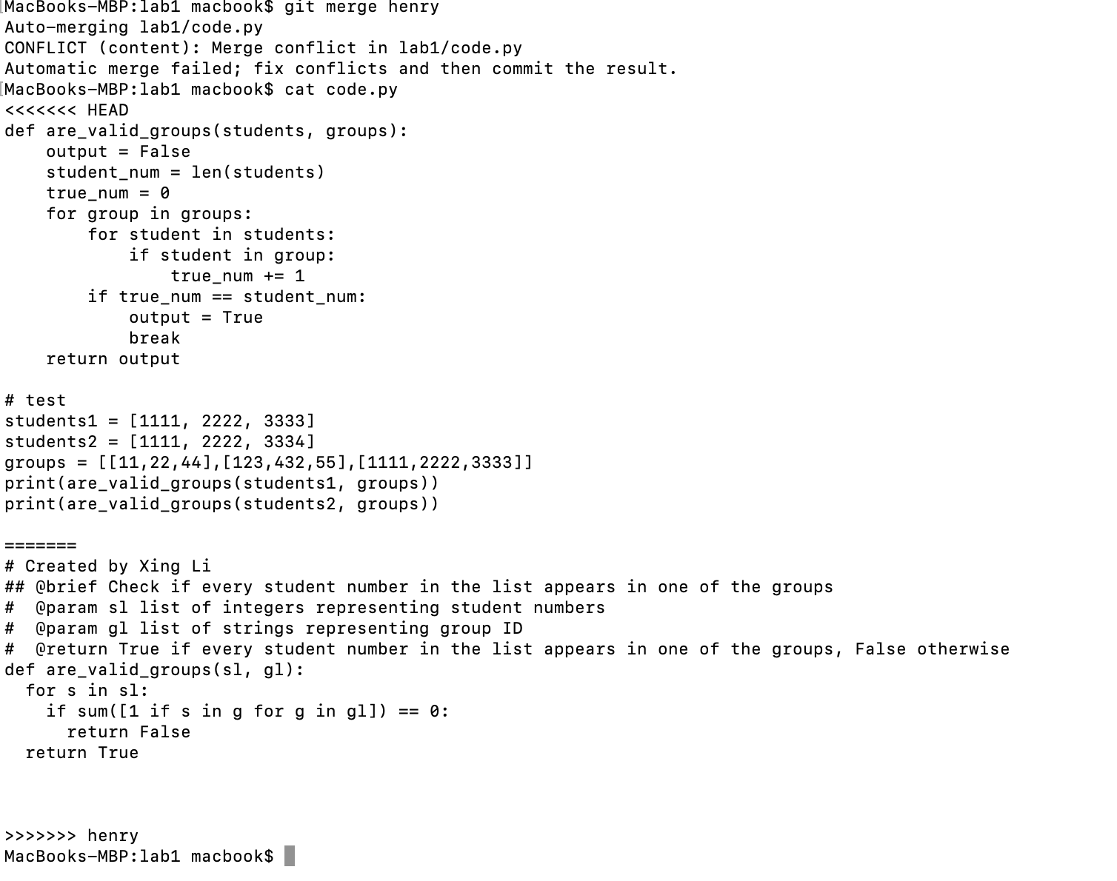

We chose to keep both code blocks, committed and pushed. It’s done.

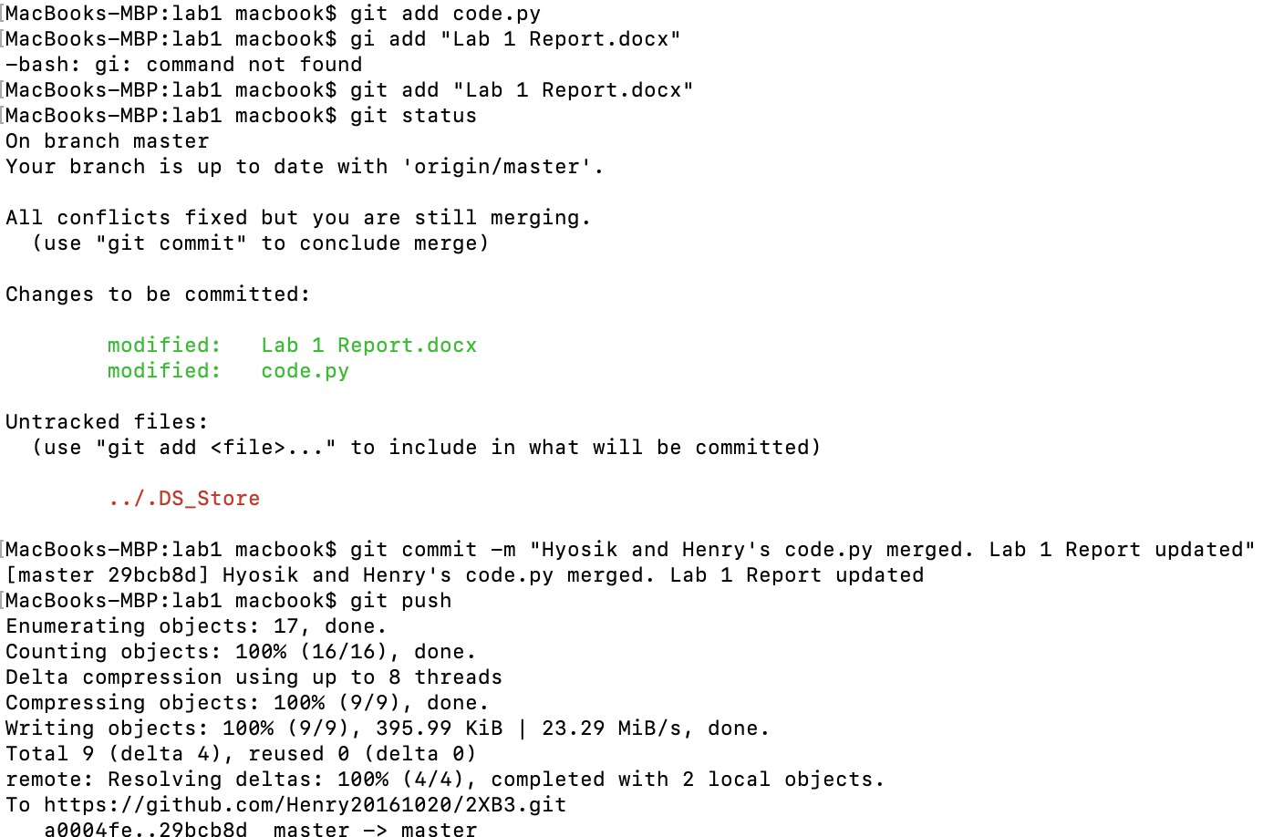

In summary, we experimented different options to resolve the conflict, and finally we found that the most straightforward way is to pull the origin, edit the conflicts in an editor and commit to merge.

## Approach 3

Finally, we used the most straightforward approach and successfully resolve the conflict efficiently

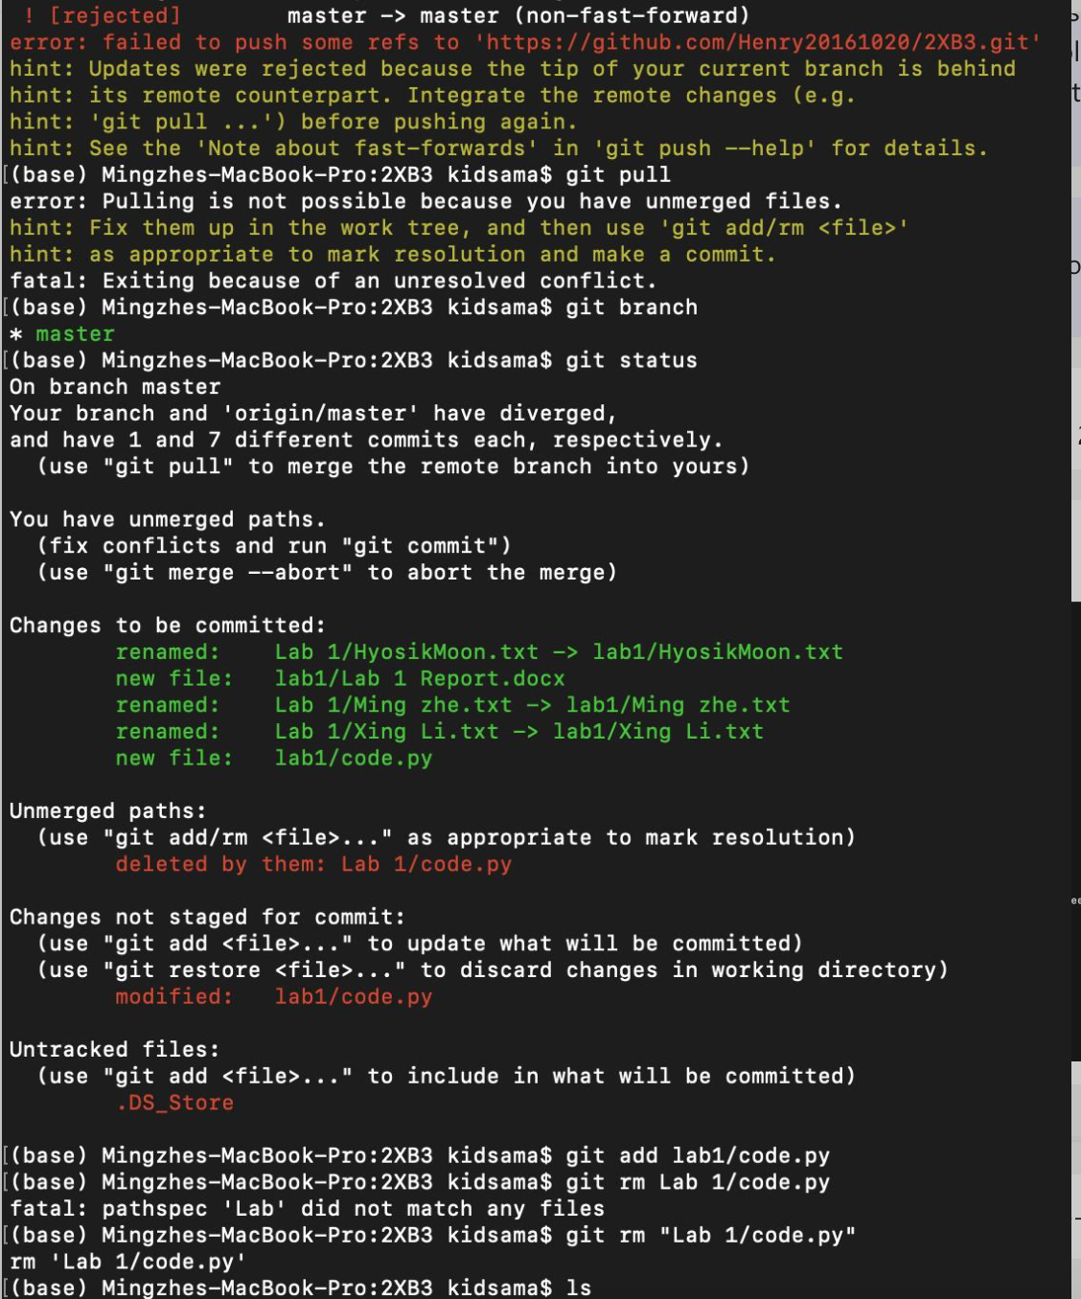

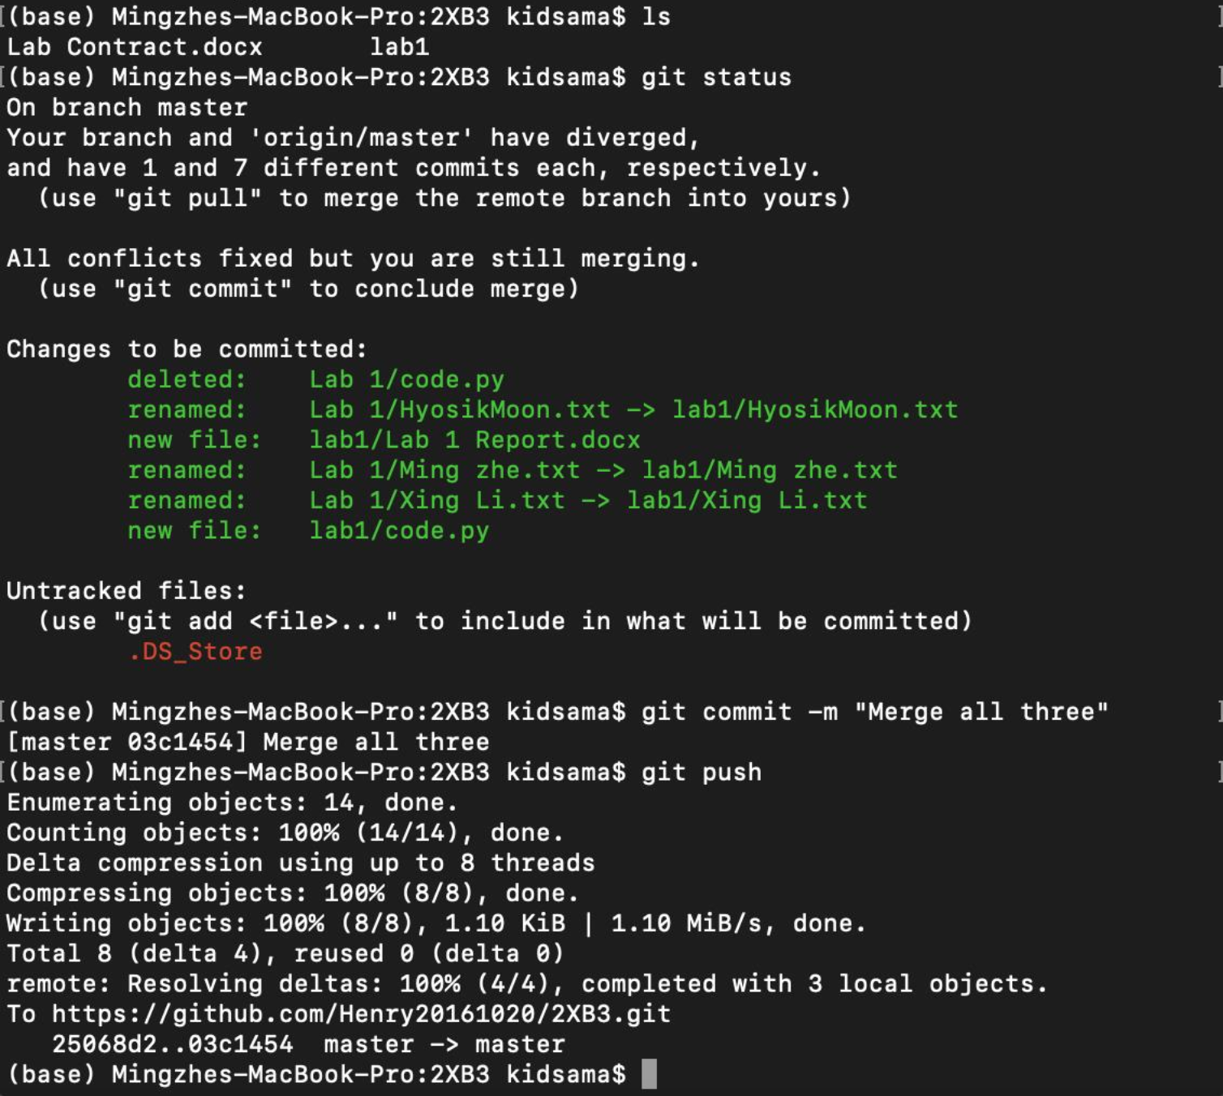

# Player and Adversary

## First Round (Player = Hyosik, Adversary = Xing, Writer = Hyosik)

1. The player1(master branch) modified the code, and pushed it. But pushing failed, because adversaries modified the code and pushed it earlier.

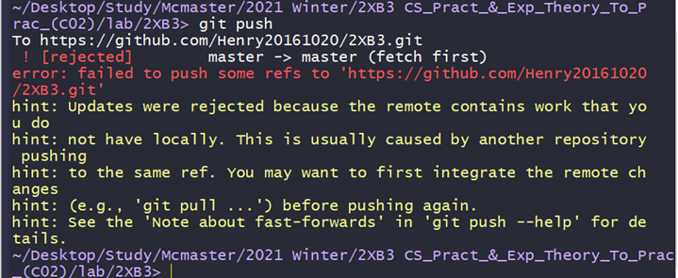

2. The player1(master branch) pulled again, and modified the code.

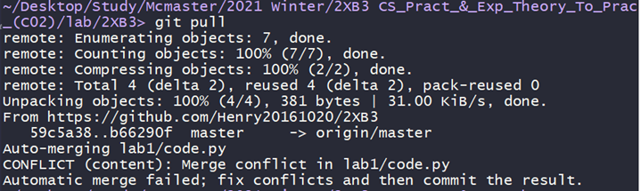

Before modify

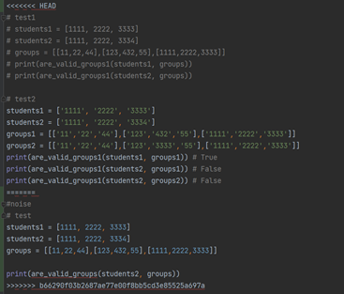

After modify

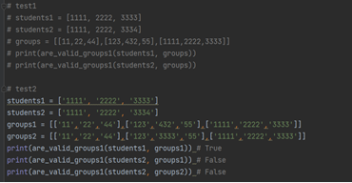

3. The player1(master branch) added, committed, and pushed again, but it also failed. > Maybe one of the adversaries was also on the master branch, so the player one failed to push the file.

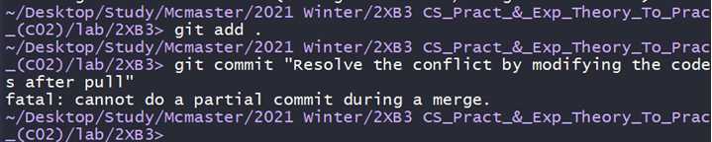

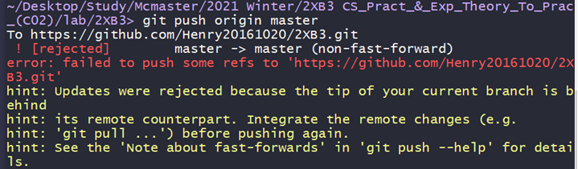

1. The player1 changed the branch from master to branch1, repeated the process, and it succeeded.

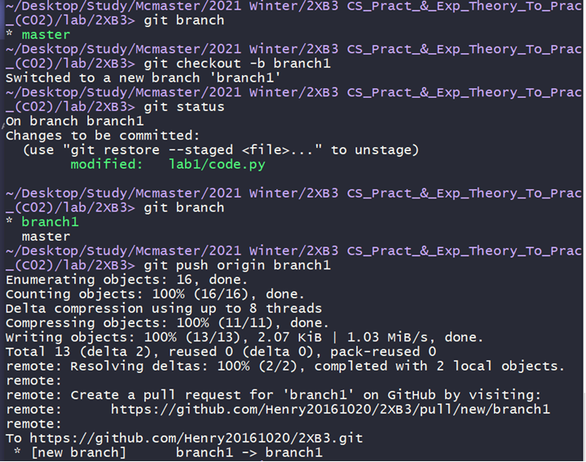

1. When the player1(branch1) checked ‘git status’ it was on stage, so he pushed it again with commit ‘Upload 2’.

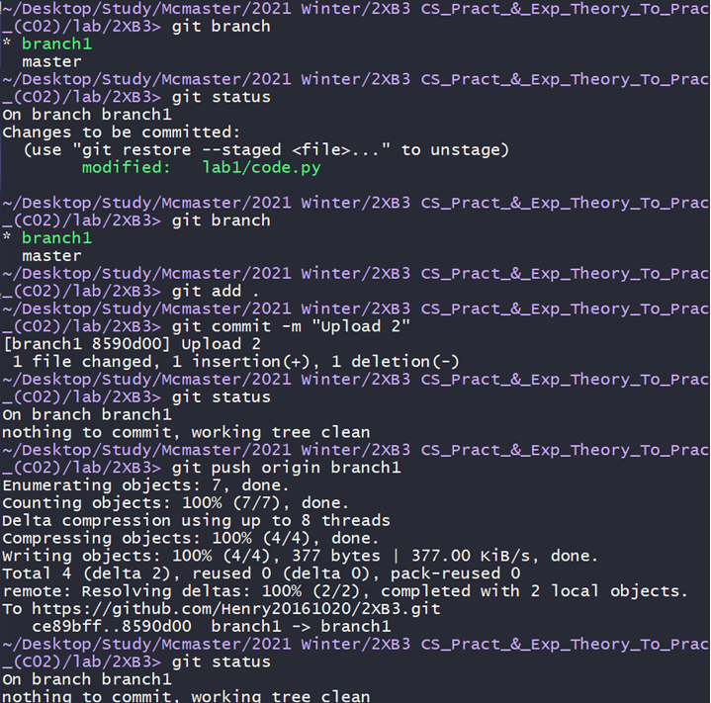

One of the adversaries’ branch(master).

‘code.py’ was not updated.

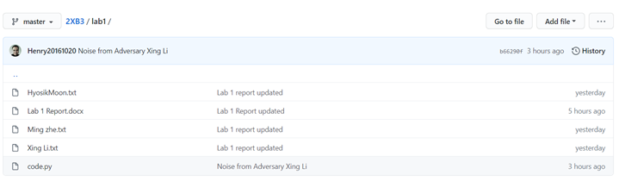

But the player1(branch1)’s file was uploaded.

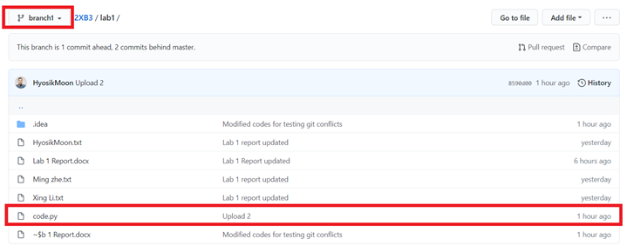Page Break

6. The player1(branch1 -> master) changed the branch from branch1 to master. When he pulled, CONFLICT appeared.

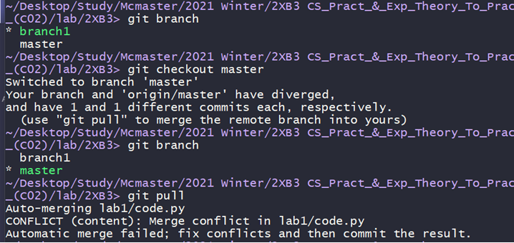

7. When the player1(master) changed the branch, error appeared. It seemed that because he pulled from the master branch, the python file changed. So he modified the file again.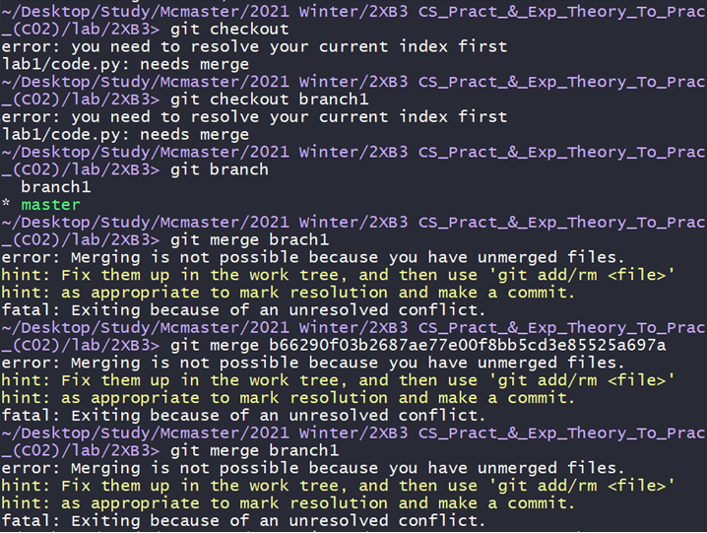

Before modify

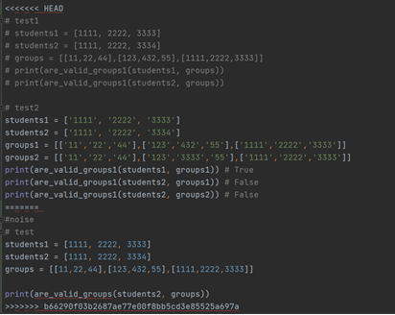

After modify

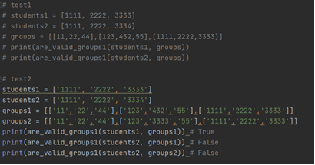

Page Break

8. After changing the code again, the player1 added, committed, and pushed the file again. And It worked.

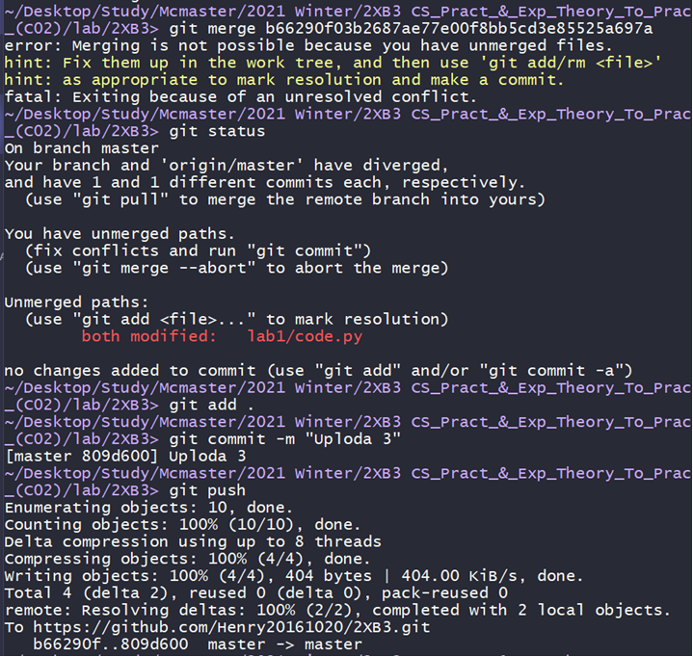

File updated(Upload3) !.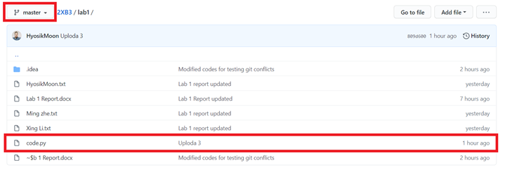

* Discussion

1. Why didn't it work when the player1(master branch) tried to push at first? Maybe one of the adversaries had been online as a master branch too. After an hour when the adversary was logged out automatically, the player1(master branch) can push the file.

Answer by Xing: There could be some updates from other collaborators between two of your pulls when you are resolving merge conflicts. This might happen if the conflict resolving took you a long time.

2. In order to avoid conflicts, modify codes at a different branch. (* Don’t modify it on the master branch.)

Answer by Xing: I think it’s a good habit. The merge will happen between the branch and the master.

3. When conflicts happen, pull the code again, modify, and push it. (* or Merge other branches when they are using different branches)

Answer by Xing: When encountering conflicts during pulling, git will automatically merge. If automatic merge fails, it will tell us which files cause the failure. Then we can modify, commit and push.

## Second Round (Player = Xing Li, Adversary = Mingzhe Wang, Writer = Xing Li)

After modification, I pulled the origin. As expected, there is merge conflict in lab1/code.py because of adversary.

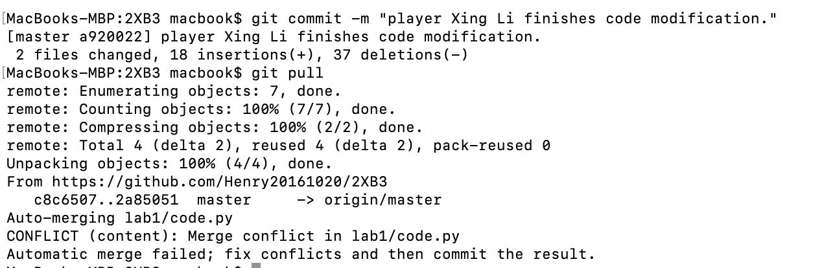

I need to clean those messages caused by adversary

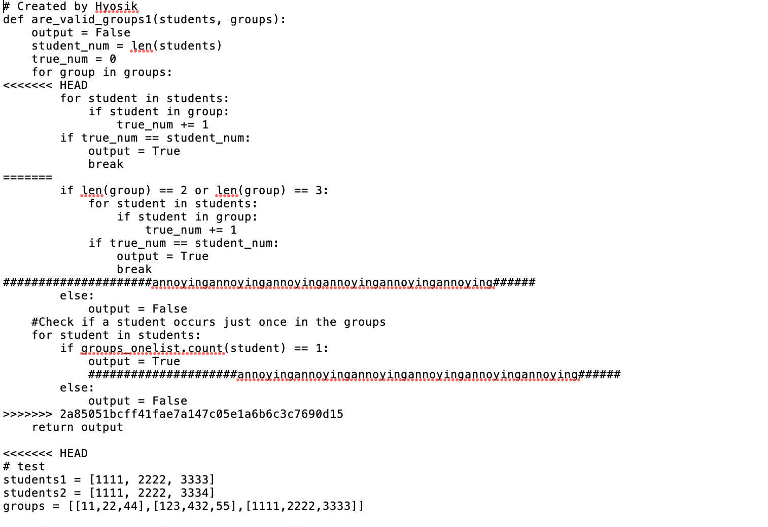

I committed the merge, and I pulled again to verify there was no change in the origin when I was resolving the conflicts. Then I pushed my update.

## Third Round (Player = Mingzhe Wang, Adversary = Hyosik, Writer = Mingzhe Wang)

1. In this round, I experimented “git reset”. Before the game began, I pulled from the remote server and made sure my repositories are updated.

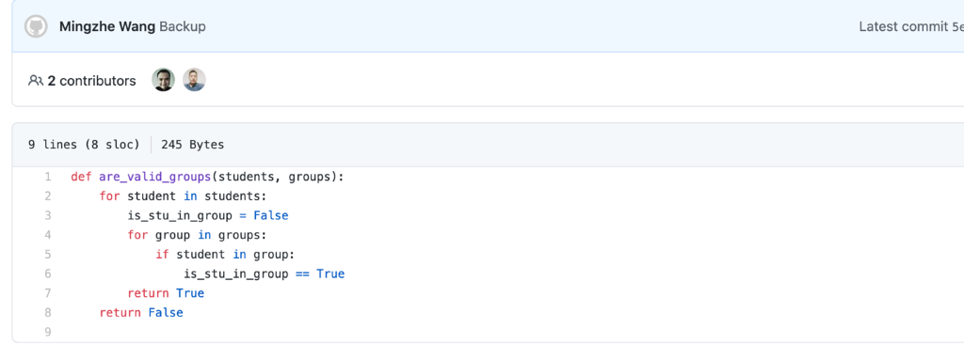



2.Then I started to revise my code in my local machine. 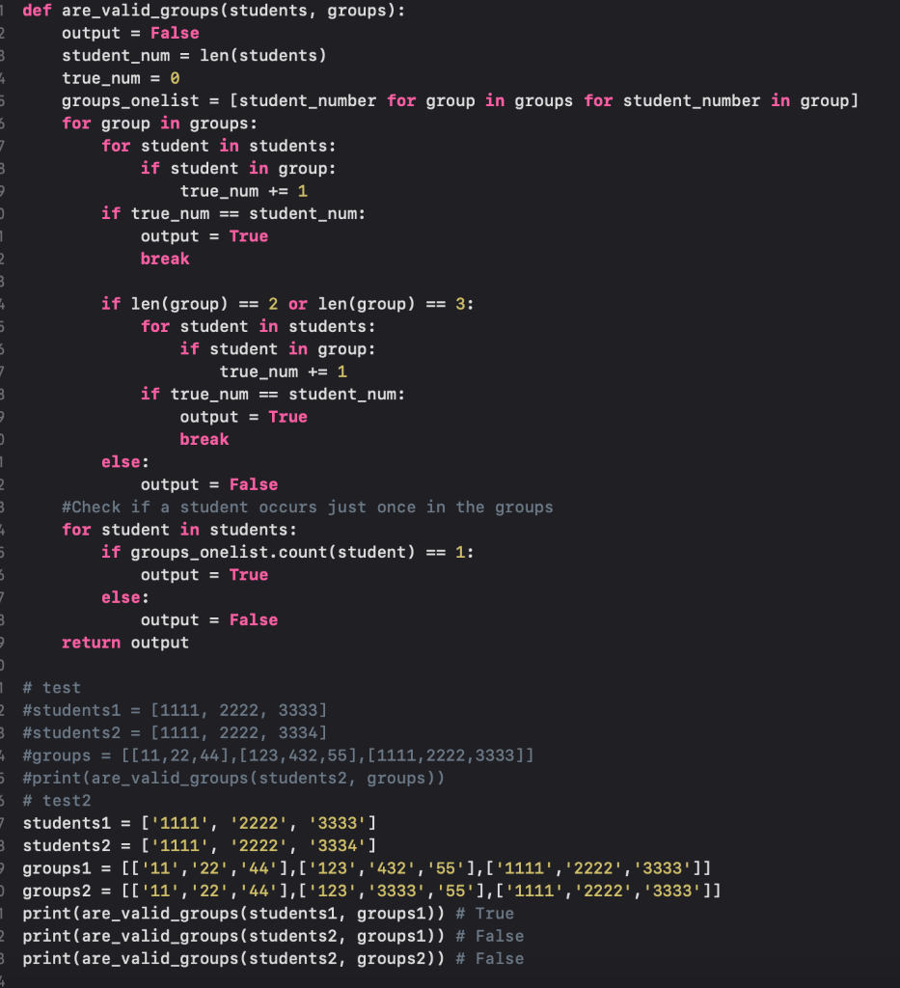

3. At the meantime, the adversary was making some noises. I noticed that the code.py file in the server at that time was changed to the following:

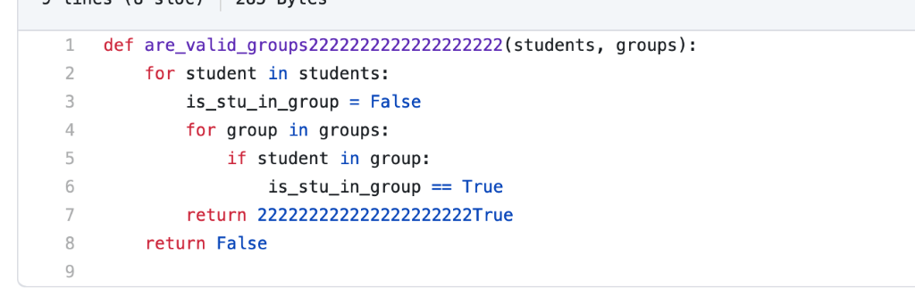

4.  Then I tried to push my revised code,  but  I got some warnings of rejecting the push.

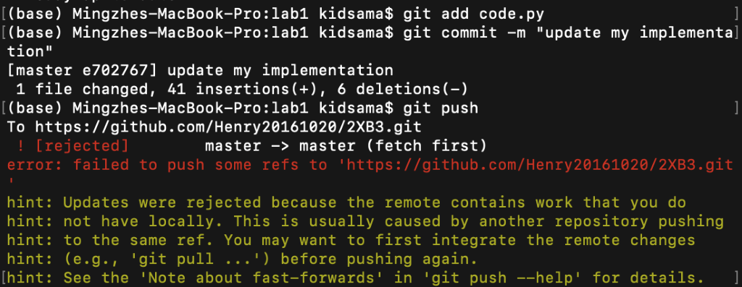

5. To resolve this conflict, I pulled from the server, and noticed that there are some conflicts happening in the file.

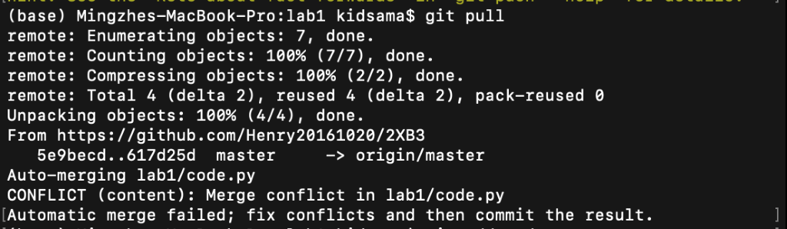

6. Then I went to the file and checked the conflicts.

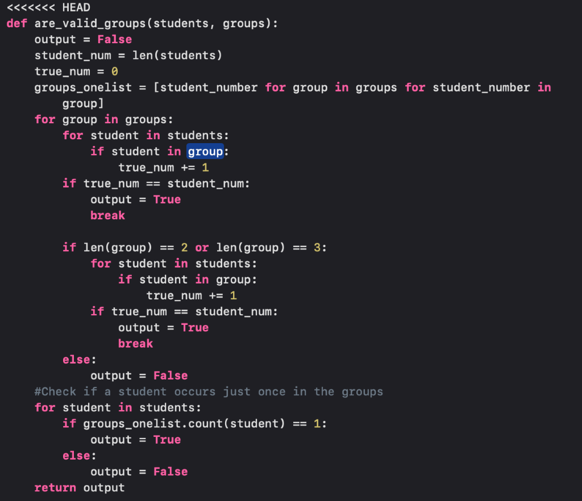

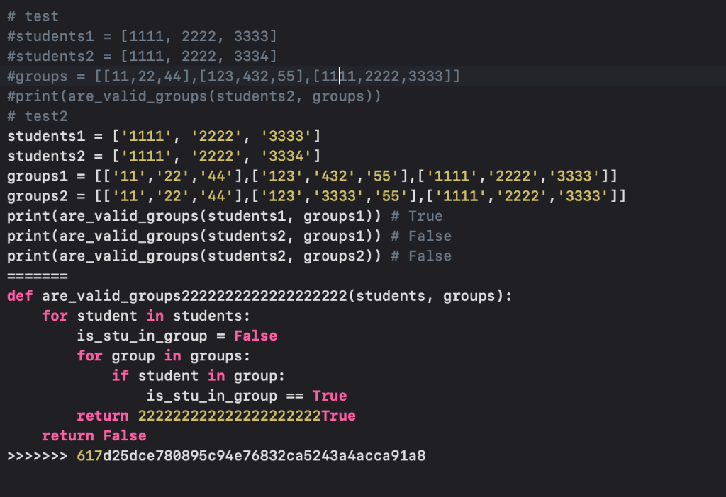

7. I selected the part that I want to be resolved and then remove the noising part.

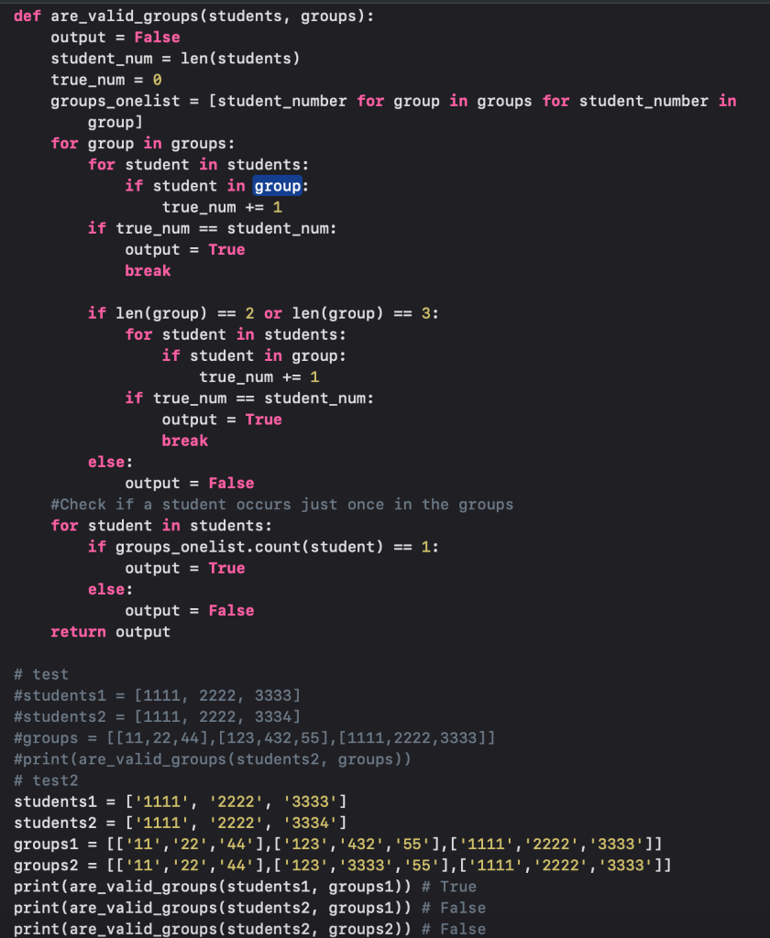

8. After finishing this, I tried to push again. This time, there’s no warning showed.

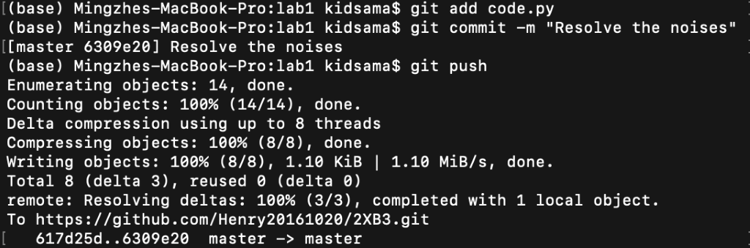

9. After my push was finished, the code.py in the server was showed as the following: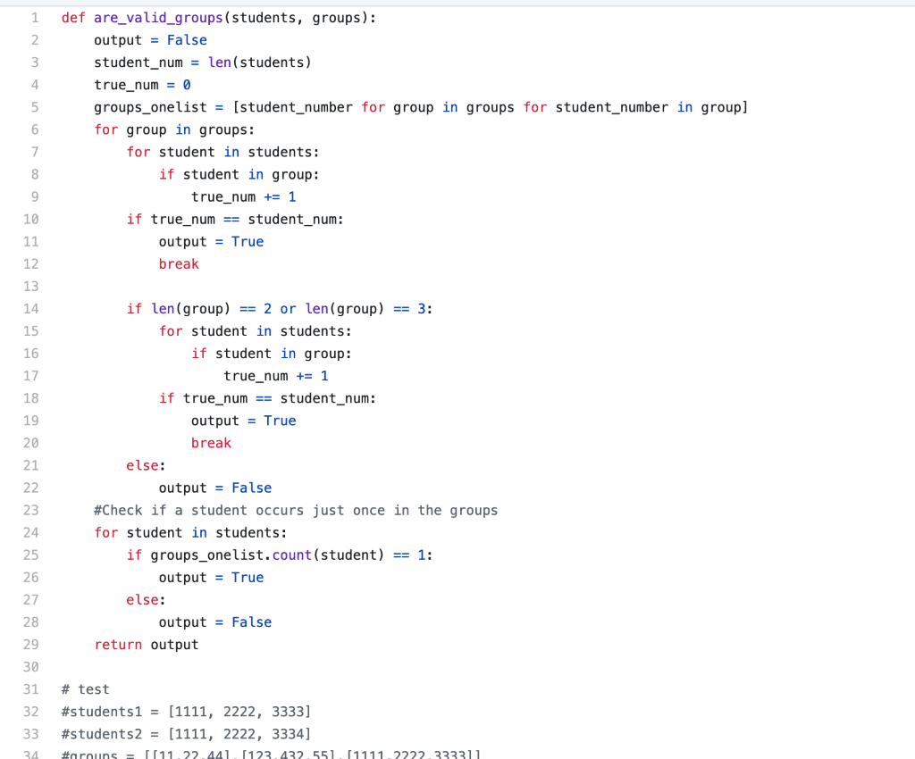

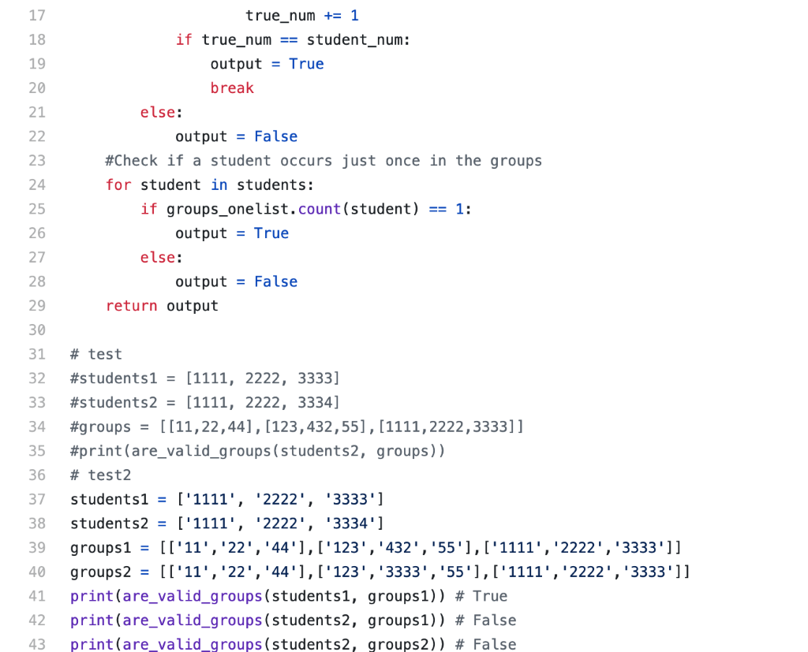

10. At last, we used command “git reset –hard [commit number]” and “git push -f” to reset the commit to let the remote server being prepared for the next round of game.

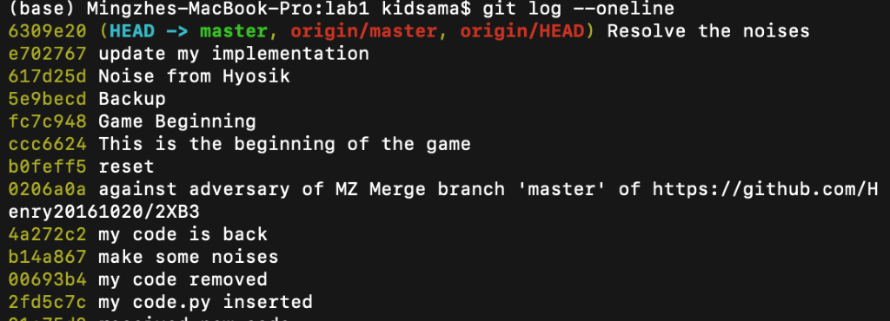

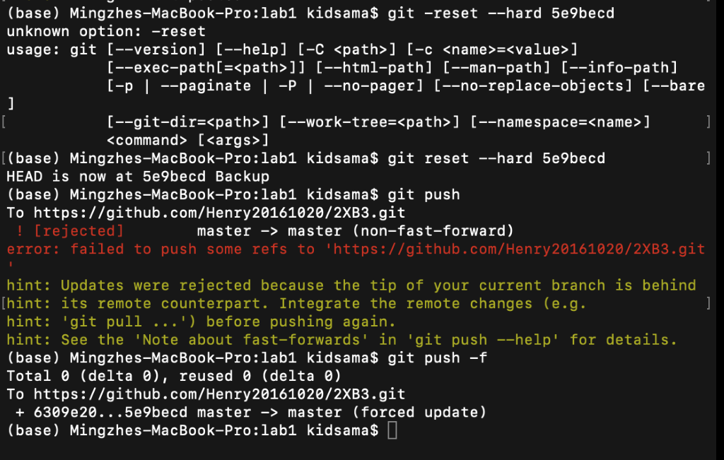

The code.py file on the server was reset to the beginning status as the following:

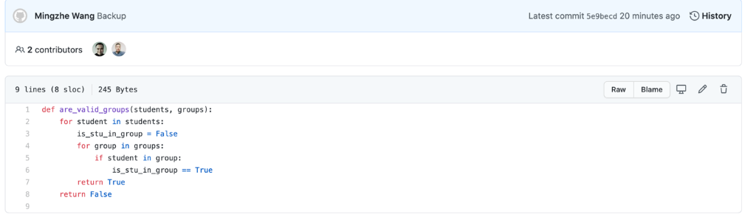

11.This is the whole record of my terminal during that time.

(base) Mingzhes-MacBook-Pro:lab1 kidsama$ git pull

Already up to date.

(base) Mingzhes-MacBook-Pro:lab1 kidsama$ git add code.py

(base) Mingzhes-MacBook-Pro:lab1 kidsama$ git commit -m "update my implementation"

[master e702767] update my implementation

 1 file changed, 41 insertions(+), 6 deletions(-)

(base) Mingzhes-MacBook-Pro:lab1 kidsama$ git push

To https://github.com/Henry20161020/2XB3.git

 ! [rejected]        master -> master (fetch first)

error: failed to push some refs to 'https://github.com/Henry20161020/2XB3.git'

hint: Updates were rejected because the remote contains work that you do

hint: not have locally. This is usually caused by another repository pushing

hint: to the same ref. You may want to first integrate the remote changes

hint: (e.g., 'git pull ...') before pushing again.

hint: See the 'Note about fast-forwards' in 'git push --help' for details.

(base) Mingzhes-MacBook-Pro:lab1 kidsama$ git pull

remote: Enumerating objects: 7, done.

remote: Counting objects: 100% (7/7), done.

remote: Compressing objects: 100% (2/2), done.

remote: Total 4 (delta 2), reused 4 (delta 2), pack-reused 0

Unpacking objects: 100% (4/4), done.

From https://github.com/Henry20161020/2XB3

   5e9becd..617d25d  master     -> origin/master

Auto-merging lab1/code.py

CONFLICT (content): Merge conflict in lab1/code.py

Automatic merge failed; fix conflicts and then commit the result.

(base) Mingzhes-MacBook-Pro:lab1 kidsama$ git add code.py

(base) Mingzhes-MacBook-Pro:lab1 kidsama$ git commit -m "Resolve the noises"

[master 6309e20] Resolve the noises

(base) Mingzhes-MacBook-Pro:lab1 kidsama$ git push

Enumerating objects: 14, done.

Counting objects: 100% (14/14), done.

Delta compression using up to 8 threads

Compressing objects: 100% (8/8), done.

Writing objects: 100% (8/8), 1.10 KiB | 1.10 MiB/s, done.

Total 8 (delta 3), reused 0 (delta 0)

remote: Resolving deltas: 100% (3/3), completed with 1 local object.

To https://github.com/Henry20161020/2XB3.git

   617d25d..6309e20  master -> master

(base) Mingzhes-MacBook-Pro:lab1 kidsama$ git log --oneline

6309e20 (**HEAD -> master**, **origin/master**, **origin/HEAD**) Resolve the noises

e702767 update my implementation

617d25d Noise from Hyosik

5e9becd Backup

fc7c948 Game Beginning

ccc6624 This is the beginning of the game

b0feff5 reset

0206a0a against adversary of MZ Merge branch 'master' of https://github.com/Henry20161020/2XB3

4a272c2 my code is back

b14a867 make some noises

00693b4 my code removed

2fd5c7c my code.py inserted

31c75d2 received new code

5bbf479 resolve conflict_Hyosik

6f45251 Hyosik's file2

2e102e9 Mingzhe's code

fa9986c Reset

3b2dfe7 Mingzhe's code

8d0ea6a everything reset

d77970d Lab 1 report updated

69bc25d Adversary message cleaned and merged

a920022 player Xing Li finishes code modification.

2a85051 make some noises

c8c6507 Lab 1 Report Updated

2ac1143 Merge branch 'branch1'

809d600 Uploda 3

8590d00 (**origin/branch1**) Upload 2

ce89bff Modified codes for testing git conflicts

b66290f Noise from Adversary Xing Li

59c5a38 Lab 1 Report updated

03c1454 Merge all three

6eeef9f implement are_valid_groups

25068d2 Lab 1 Report updated

29bcb8d Hyosik and Henry's code.py merged. Lab 1 Report updated

fc4072b code.py modified by Xing Li

a0004fe Add code.py file, Hyosik

4e8af91 Delete ~$b 1 Report.docx

f36a4ec Lab 1 folder removed

bf02d6e Lab 1 report updated

9c6d23a Hyosik and Mingzhe txt merged

694fbb6 Upload Hyosik's file

d2dc22a empty code.py posted

765049c This is Mingzhe's txt

84776e1 Lab contract modified with task complete message required

42e2641 Xing Li txt posted

(base) Mingzhes-MacBook-Pro:lab1 kidsama$ git -reset --hard 5e9becd

unknown option: -reset

usage: git [--version] [--help] [-C <path>] [-c <name>=<value>]

           [--exec-path[=<path>]] [--html-path] [--man-path] [--info-path]

           [-p | --paginate | -P | --no-pager] [--no-replace-objects] [--bare]

           [--git-dir=<path>] [--work-tree=<path>] [--namespace=<name>]

           <command> [<args>]

(base) Mingzhes-MacBook-Pro:lab1 kidsama$ git reset --hard 5e9becd

HEAD is now at 5e9becd Backup

(base) Mingzhes-MacBook-Pro:lab1 kidsama$ git push

To https://github.com/Henry20161020/2XB3.git

 ! [rejected]        master -> master (non-fast-forward)

error: failed to push some refs to 'https://github.com/Henry20161020/2XB3.git'

hint: Updates were rejected because the tip of your current branch is behind

hint: its remote counterpart. Integrate the remote changes (e.g.

hint: 'git pull ...') before pushing again.

hint: See the 'Note about fast-forwards' in 'git push --help' for details.

(base) Mingzhes-MacBook-Pro:lab1 kidsama$ git push -f

Total 0 (delta 0), reused 0 (delta 0)

To https://github.com/Henry20161020/2XB3.git

 + 6309e20...5e9becd master -> master (forced update)

(base) Mingzhes-MacBook-Pro:lab1 kidsama$

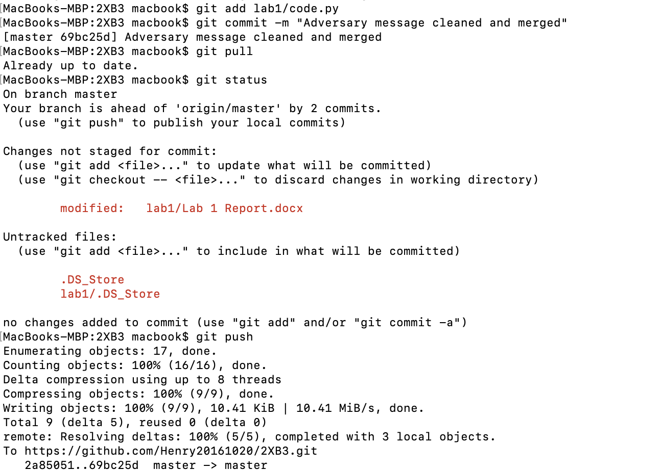

# What is Learned about Conflicts?

Throughout the lab, we encountered different conflicts requiring merge. The easiest one to handle is new file either in the origin or in the local environment. They can be automatically merged. The one requiring more efforts are file name changes or folder name changes. Both git add and git rm are required. The trickiest one is the conflicts in one file. This kind of conflict cannot be automatically merged. Git pull/merge, editing in a text editor and git commit are required to resolve the conflicts.

To avoid conflict issues, there could be some “good” habits. First, commit more often. As long as there is no one touching the origin repository between your pull and push, there will be no conflicts. Second, when git push failed, pull the origin first, resolve the conflict and commit to merge. This is most straightforward way to deal with conflicts.